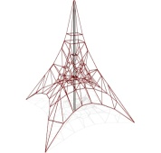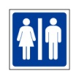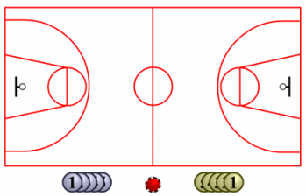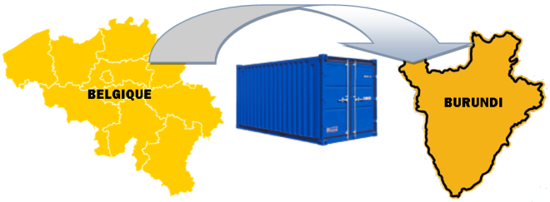

SAMEDI 30 MAI 2015

BARBECUE

BAR

RESTAURATION

DEFIS SPORTIFS

PODIUM

MERCIS !

STANDS extrascolaire

JETONS

STANDS 10/12

STANDS 3/4

CHÂTEAU GONFLABLE

BARBE A PAPA

BAR A JUS

STANDS 5/8 VIOLET

STANDS 8/10

TOMBOLA

JETONS